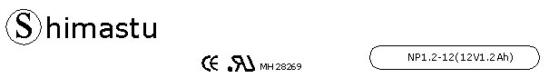

PHYSICAL SPECIFICATION
Nominal Voltage  Nominal Capacity (20HR) |  |  |  | 12V  1.2Ah |  | 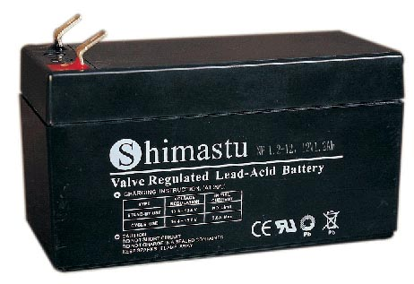
Dimension |  | Length  Width  Container Height  Total Height |  | 97±1mm （3.82 inches)  44±1mm (1.73 inches)  53±1mm (2.09 inches)  59±1mm (2.32 inches)
Weight |  |  |  | Approx. 0.59 Kg ( 1.30lbs)
Standard Terminal |  |  |  | F1-Fasten Tab No.187E
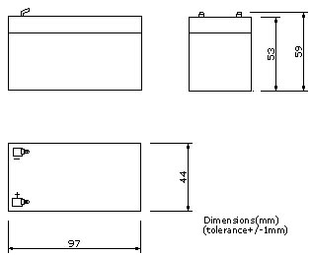 |  |  |  |  |  | 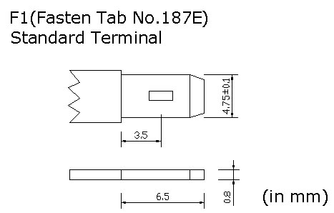

ELECTRICAL SPECIFICATION
Characteristics |  |  |  |  |  | Discharge curves @ 25℃ (77 °F)
Capacity |  |  | 20 hour rate (0.06A)  10 hour rate (0.108A)  5 hour rate (0.204A)  3 hour rate (0.3A)  1hour rate (0.72A) |  | 1.2Ah  1.14Ah  1.02Ah  0.9Ah  0.72Ah | 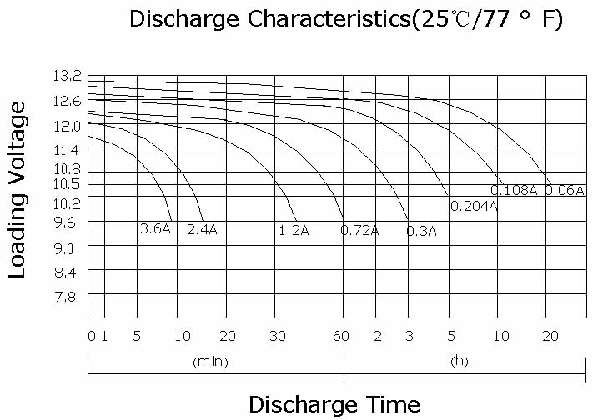
Capacity affected  by temperature |  |  | 40℃ （104 ⁰F）  25℃ （77 ⁰F）  0℃ （32 ⁰F） |  | 102%  100%  85%
Internal Resistance |  |  | Full charged battery (25℃,77 ⁰F) 50mΩ
Constant Voltage  Charge | Cycle |  | Initial Charging Current less than 0.36A  Voltage 14.4~15.0V at 25℃ (77 ⁰F )  Temperature Coefficient –30mV/℃
Constant Voltage  Charge | Standby |  | No limit on Initial Charging Current  Voltage 13.5~13.8V at 25℃ (77 ⁰F )  Temperature Coefficient –20mV/℃

