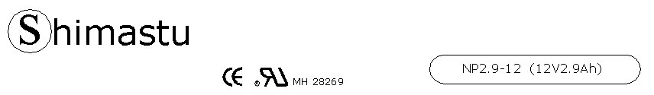

PHYSICAL SPECIFICATION
Nominal Voltage  Nominal Capacity (20HR) |  |  |  | 12V  2.9Ah |  | 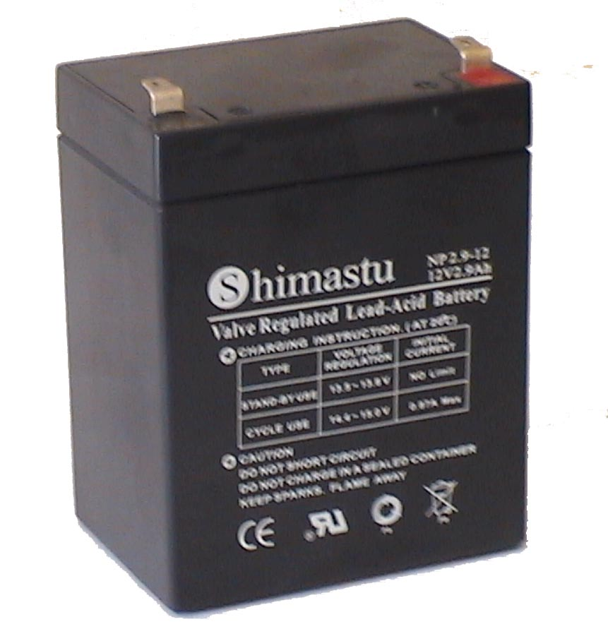
Dimension |  | Length  Width  Container Height  Total Height |  | 79±1mm （3.11 inches）  56±1mm (2.20 inches)  99±1mm (3.90 inches)  104±1mm (4.09 inches)
Weight |  |  |  | Approx. 1.05 Kg (2.31lbs)
Standard Terminal |  |  |  | Fasten Tab No.187E
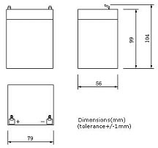 |  |  |  |  |  | 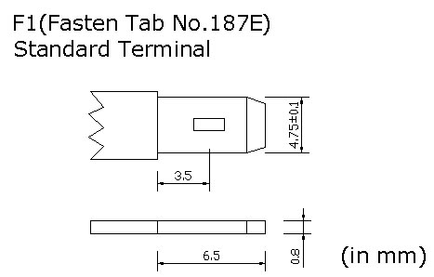

ELECTRICAL SPECIFICATION
Characteristics |  |  |  |  |  | Discharge curves @ 25℃ (77 °F)
Capacity |  |  | 20 hour rate (0.145A)  10 hour rate (0.261A)  5 hour rate (0.493A)  3 hour rate (0.725A)  1hour rate (1.74A) |  | 2.9Ah  2.7Ah  2.5Ah  2.2Ah  1.8Ah | 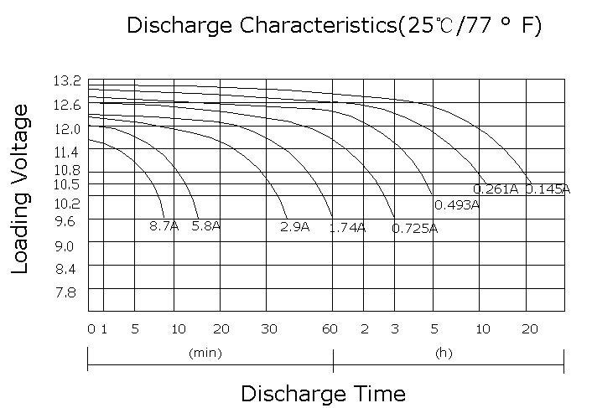
Capacity affected  by temperature |  |  | 40℃ （104 ⁰F）  25℃ （77 ⁰F）  0℃ （32 ⁰F） |  | 102%  100%  85%
Internal Resistance |  |  | Full charged battery (25℃,77 ⁰F) 25mΩ
Constant Voltage  Charge | Cycle |  | Initial Charging Current less than 0.87A  Voltage 14.4~15.0V at 25℃ (77 ⁰F )  Temperature Coefficient –30mV/℃
Constant Voltage  Charge | Standby |  | No limit on Initial Charging Current  Voltage 13.5~13.8V at 25℃ (77 ⁰F )  Temperature Coefficient –20mV/℃

