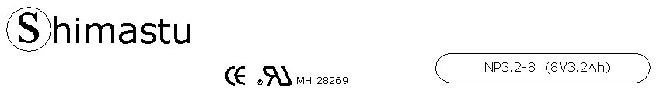

PHYSICAL SPECIFICATION
Nominal Voltage  Nominal Capacity (20HR) |  |  |  | 8V  3.2Ah |  | 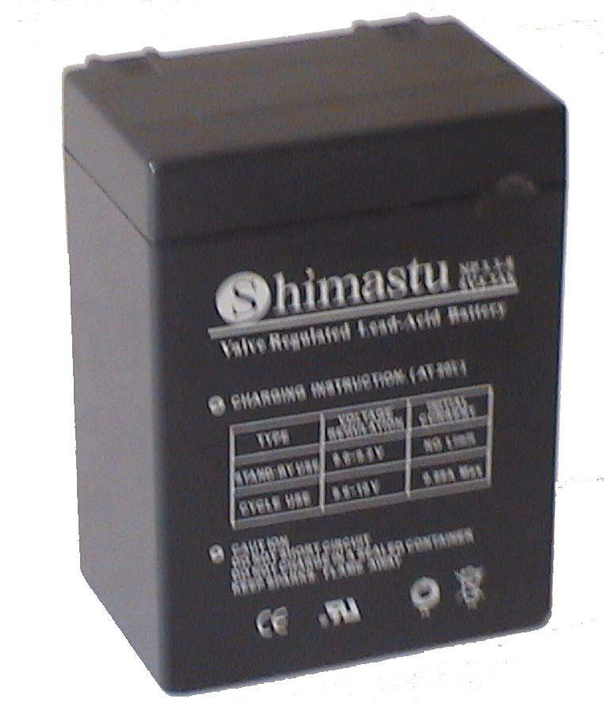
Dimension |  | Length  Width  Container Height  Total Height |  | 68±1mm (2.68 inches)  48±1mm (1.89 inches)  90±1mm (3.54 inches)  90±1mm (3.54 inches)
Weight |  |  |  | Approx. 0.79 Kg ( 1.74lbs)
Standard Terminal |  |  |  | Fasten Tab No.187E
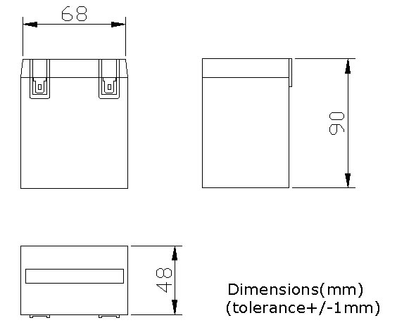 |  |  |  |  |  | 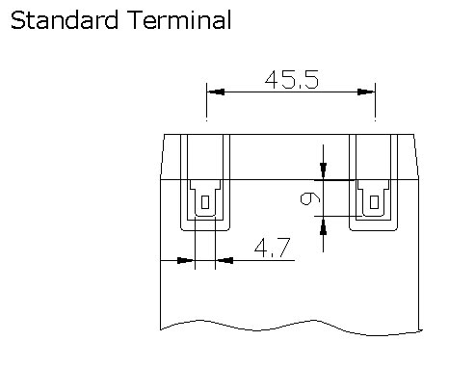

ELECTRICAL SPECIFICATION
Characteristics |  |  |  |  |  | Discharge curves @ 25℃ (77 °F)
Capacity |  |  | 20 hour rate (0.16A)  10 hour rate (0.288A)  5 hour rate (0.544A)  3 hour rate (0.8A)  1hour rate (1.92A) |  | 3.2Ah  3.0Ah  2.8Ah  2.4Ah  2Ah | 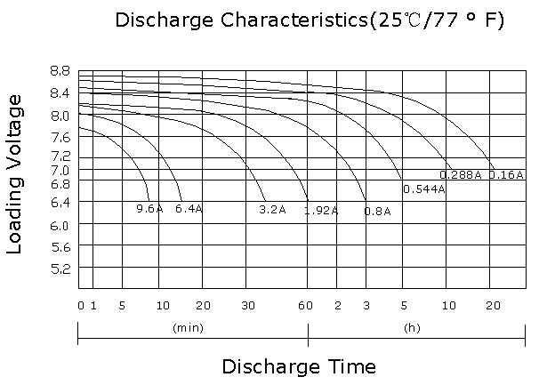
Capacity affected  by temperature |  |  | 40℃ （104 ⁰F）  25℃ （77 ⁰F）  0℃ （32 ⁰F） |  | 102%  100%  85%
Internal Resistance |  |  | Full charged battery (25℃,77 ⁰F) 25mΩ
Constant Voltage  Charge | Cycle |  | Initial Charging Current less than 0.96A  Voltage 9.6~10V at 25℃ (77 ⁰F )  Temperature Coefficient –18mV/℃
Constant Voltage  Charge | Standby |  | No limit on Initial Charging Current  Voltage 9~9.2V at 25℃ (77 ⁰F )  Temperature Coefficient –18mV/℃

