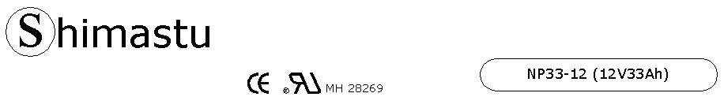

PHYSICAL SPECIFICATION
Nominal Voltage  Nominal Capacity (10HR) |  |  |  | 12V  33Ah |  | 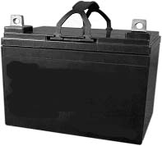
Dimension |  | Length  Width  Container Height  Total Height |  | 196±1mm （7.72 inches)  130±1mm (5.12 inches)  163±1mm (6.42 inches)  179±1mm (7.05 inches)
Weight |  |  |  | Approx. 11.2 Kg ( 24.68lbs)
Standard Terminal |  |  |  | Bolt-and-nut lead terminal  Bolt Type: M6
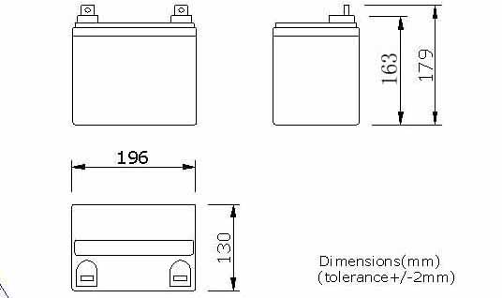 |  |  |  |  |  | 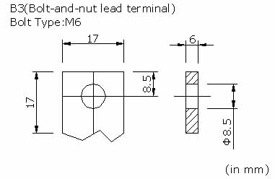

ELECTRICAL SPECIFICATION
Characteristics |  |  |  |  |  | Discharge curves @ 25℃ (77 °F)
Capacity |  |  | 10 hour rate (3.5A)  5 hour rate (5.95A)  3 hour rate (8.48A)  1hour rate (21A) |  | 33Ah  30Ah  26.5Ah  21Ah | 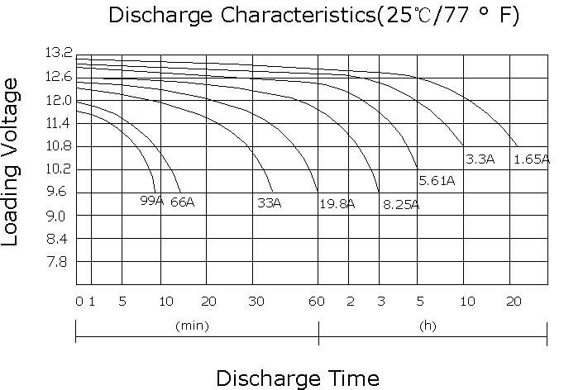
Capacity affected  by temperature |  |  | 40℃ （104 ⁰F）  25℃ （77 ⁰F）  0℃ （32 ⁰F） |  | 102%  100%  85%
Internal Resistance |  |  | Full charged battery (25℃,77 ⁰F) 10mΩ
Constant Voltage  Charge | Cycle |  | Initial Charging Current less than 8.2A  Voltage 14.1~14.4V at 25℃ (77 ⁰F )  Temperature Coefficient –18mV/℃
Constant Voltage  Charge | Standby |  | No limit on Initial Charging Current  Voltage 13.5~13.8V at 25℃ (77 ⁰F )  Temperature Coefficient –18mV/℃

