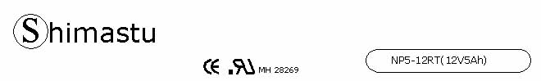

PHYSICAL SPECIFICATION
Nominal Voltage  Nominal Capacity (20HR) |  |  |  | 12V  5Ah |  | 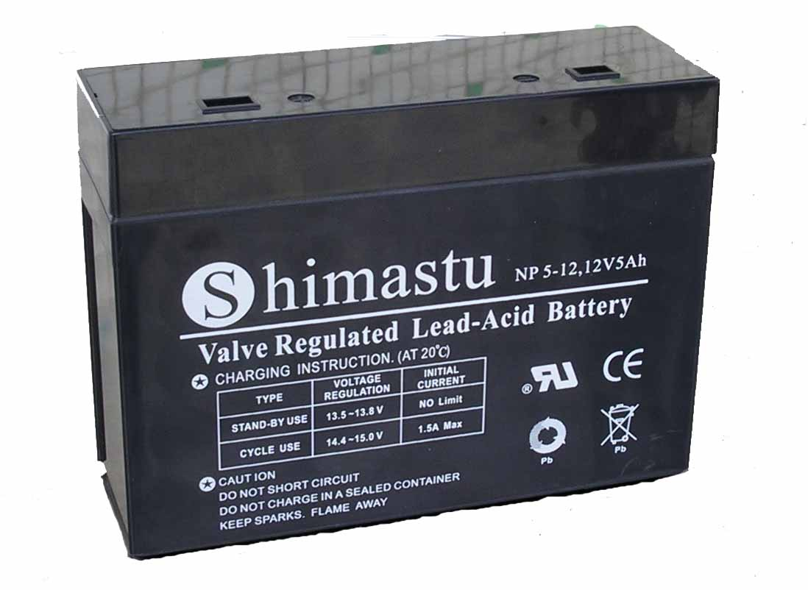
Dimension |  | Length  Width  Container Height  Total Height |  | 140±1mm （5.51 inches)  48±1mm (1.89 inches)  102±1mm (4.05 inches)  102±1mm (4.02 inches)
Weight |  |  |  | Approx. 1.6 Kg (3.53lbs)
Standard Terminal |  |  |  | Fasten Tab
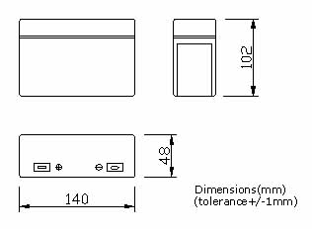 |  |  |  |  |  | 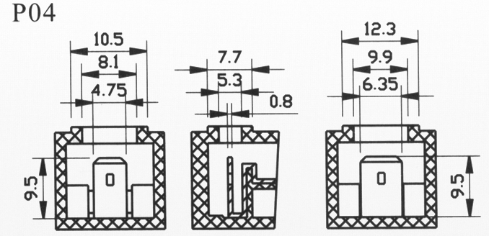

ELECTRICAL SPECIFICATION
Characteristics |  |  |  |  |  | Discharge curves（A） @ 25℃ (77 °F)
Capacity |  |  | 20 hour rate (0.25A)  10 hour rate (0.45A)  5 hour rate (0.85A)  3 hour rate (1.25A)  1hour rate (3A) |  | 5Ah  4.7Ah  4.3Ah  3.8Ah  3Ah | 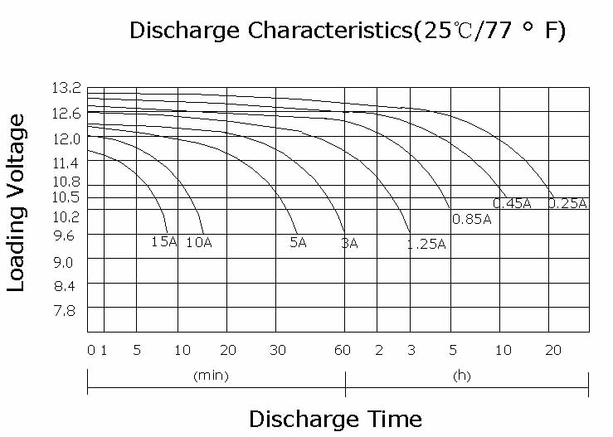
Capacity affected  by temperature |  |  | 40℃ （104 ⁰F）  25℃ （77 ⁰F）  0℃ （32 ⁰F） |  | 102%  100%  85%
Internal Resistance |  |  | Full charged battery (25℃,77 ⁰F) 40mΩ
Constant Voltage  Charge | Cycle |  | Initial Charging Current less than 1.5A  Voltage 14.4~15.0V at 25℃ (77 ⁰F )  Temperature Coefficient –30mV/℃
Constant Voltage  Charge | Standby |  | No limit on Initial Charging Current  Voltage 13.5~13.8V at 25℃ (77 ⁰F )  Temperature Coefficient –20mV/℃

