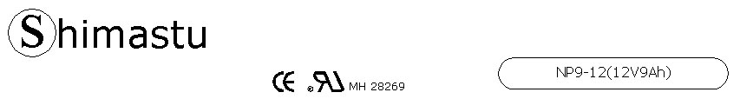

PHYSICAL SPECIFICATION
Nominal Voltage  Nominal Capacity (20HR) |  |  |  | 12V  9Ah |  | 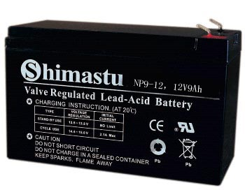
Dimension |  | Length  Width  Container Height  Total Height |  | 151±1mm （5.94 inches)  65±1mm (2.56 inches)  111±1mm (4.37 inches)  118±1mm (4.65 inches)
Weight |  |  |  | Approx. 3.15 Kg (6.94lbs)
Standard Terminal |  |  |  | Fasten Tab No.187E
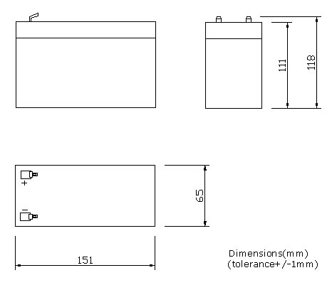 |  |  |  |  |  | 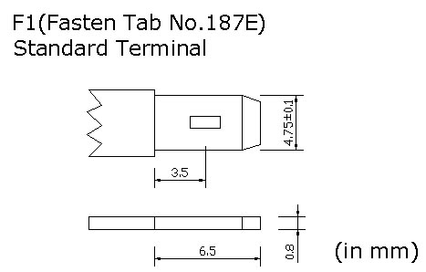

ELECTRICAL SPECIFICATION
Characteristics |  |  |  |  |  | Discharge curves @ 25℃ (77 °F)
Capacity |  |  | 20 hour rate (0.45A)  10 hour rate (0.81A)  5 hour rate (1.53A)  3 hour rate (2.25A)  1hour rate (5.4A) |  | 9Ah  8.5Ah  7.7Ah  6.8Ah  5.4Ah | 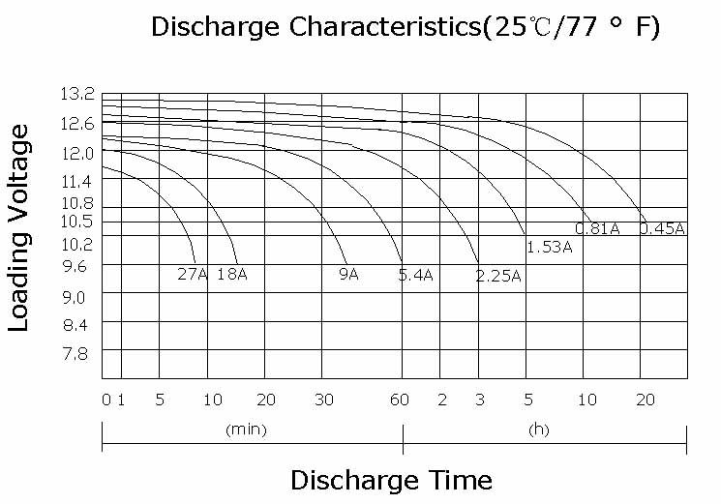
Capacity affected  by temperature |  |  | 40℃ （104 ⁰F）  25℃ （77 ⁰F）  0℃ （32 ⁰F） |  | 102%  100%  85%
Internal Resistance |  |  | Full charged battery (25℃,77 ⁰F) 25mΩ
Constant Voltage  Charge | Cycle |  | Initial Charging Current less than 2.7A  Voltage 14.4~15.0V at 25℃ (77 ⁰F )  Temperature Coefficient –30mV/℃
Constant Voltage  Charge | Standby |  | No limit on Initial Charging Current  Voltage 13.5~13.8V at 25℃ (77 ⁰F )  Temperature Coefficient –20mV/℃

