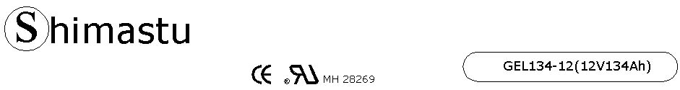

PHYSICAL SPECIFICATION
Nominal Voltage  Nominal Capacity (10HR) |  |  |  | 12V  134Ah |  | 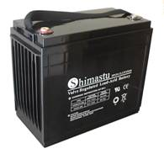
Dimension |  | Length  Width  Container Height  Total Height |  | 340±2mm （15.38 inches）  173±2mm (6.81 inches)  280±2mm (11.02 inches)  283±2mm (11.14 inches)
Weight |  |  |  | Approx. 45Kg (99.1lbs)
Standard Terminal |  |  |  | Bolt-and-nuts terminal  Bolt Type: M6
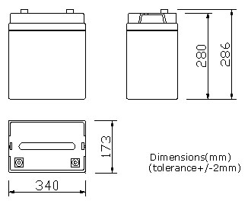 |  |  |  |  |  | 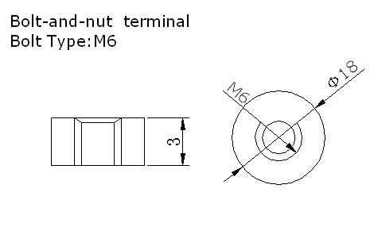

ELECTRICAL SPECIFICATION
Characteristics |  |  |  |  |  | Discharge curves @ 25℃ (77 °F)
Capacity |  |  | 10 hour rate (13.4A)  5hour rate (22.78A)  3 hour rate (33.5A)  1hour rate (80.4A) |  | 134Ah  114Ah  101Ah  81Ah | 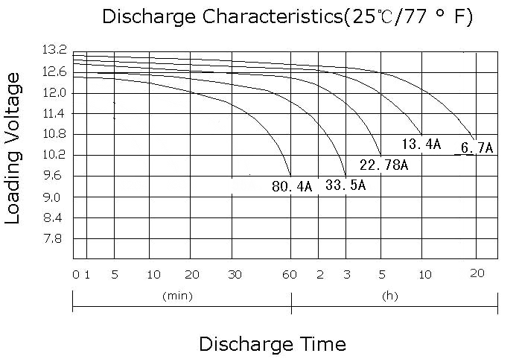
Capacity affected  by temperature |  |  | 40℃ （104 ⁰F）  25℃ （77 ⁰F）  0℃ （32 ⁰F） |  | 102%  100%  85%
Designed life |  |  | ≥720 Cycles 50% DOD (25℃)
Internal Resistance |  |  | Full charged battery (25℃,77 ⁰F)5.8mΩ
Constant Voltage  Charge | Cycle |  | Initial Charging Current less than 33.5A  Voltage 14.1~14.4V at 25℃ (77 ⁰F )  Temperature Coefficient –5mV/℃
Constant Voltage  Charge | Standby |  | No limit on Initial Charging Current  Voltage 13.5~13.8V at 25℃ (77 ⁰F )  Temperature Coefficient –3.3mV/℃

